# Noise Regime Change Detection

*Silbido* relies on noise estimates to normalize spectrograms before detecting spectral-temporal peaks. When the noise regime changes radically within a noise estimation region, the noise estimate will be too high for the quieter regions and too low for the noisier ones. The figure below shows a situation where an echo sounder is turned on. Two noise estimates are produced, one that covers the transition period, and the second during continuous operation of the echo sounder.

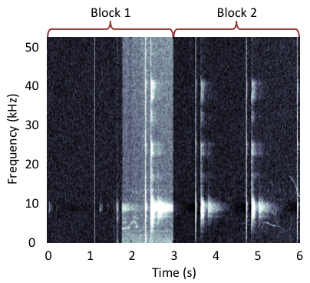

Figure - Spectrogram compensated for noise with estimates from two regions. In the first block where the echo sounder was not operating continuously, the region where the echo sounder starts is under compensated, producing signal to noise ratio estimates that are well above threshold.

Noise regime change detection is a preprocessing step that returns a list of times that are hypothesized to be boundaries between noise regimes. These can be passed to *silbido* as arguments to the detection process and the detector will ensure that noise estimates do not cross boundaries (Figure 2).

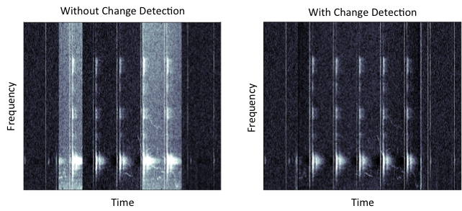

Figure – In the left spectrogram noise estimation boundaries included regions with and without echo sounder activity at the beginning and end of an echo sounder ping train. The right spectrogram shows noise compensation that recognizes the beginning and end of the echo sounder train.

Details of the noise regime detection process may be found in MacFadden (2015). The function:

changepts_s = detect_noise_changes(filename)

will produce a list of change points where changepts_s is a vector of times in s relative to the start of file. The function supports a number of settable parameters, type help detect_noise_changes_in_file for details.

These change points can be passed to the *silbido* detector with the NoiseBoundaries argument:

tonals = dtTonalsTracking(filename, 0, Inf, …

'NoiseBoundaries', changepts_s);

One can examine how change points are determined with the UIChangeDetectionTool. A basic understanding of hypothesis testing and the Bayesian information criterion are required to understand the results. A brief explanation of the displays is outlined in MacFadden (2015).

References

**MacFadden, M. S.** (2015). Improving Performance in Graph-Based Detection of Odontocete Whistles Through Graph Analysis and Noise Regime-Change. MS thesis, San Diego State University, <http://hdl.handle.net/10211.3/163393>.